Summer Infusion Parent Engagement
Families can be engaged in infusion in several ways:

Tell parents about infusion initiative
Share information about summer learning loss before and during camp, as well as what your agency is doing to prevent it. A sample letter is included below.

Encourage reading at home
See Scholastic’s Kids & Family Reading Report to see data about how many families are reading regularly with their children at home. Hint: the percentage drops off in early elementary school!
http://www.scholastic.com/readingreport/about.htm
To encourage reading at home during the summer, we provided books for students to take home and read M-Th as part of the infusion pilot. *Please note that you should expect many books to “walk away” if you let kids borrow books.* We also provided a weekly reading log for families to write down the books they read at home. Students returned the logs on Friday to earn prizes.
The reading logs were summer themed to increase motivation, some samples are included below.

Get families connected to the public library
Share information with parents about the Summer Break reading initiative through CM Public Library. (2019 information is not yet online)
https://summerbreak.cmlibrary.org/
Invite families to attend Active Reading workshops facilitated by CM Public Library (hosted at your agency or at library branches).
https://www.cmlibrary.org/active-reading

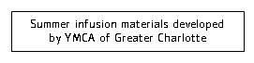

Sample parent communication about literacy infusion
Dear Parents and Caregivers,
Did you know that kids can lose up to 2 months of reading skills over the summer? This is called the “summer slide” and it means that many kids will start the new school year behind where they finished in June. The [enter agency name] is committed to helping our campers stay on track for academic success, and we are excited to include reading in our camp this summer through read alouds, choice reading and games.
Our goal is to help your child maintain their current reading level and continue to have an AWESOME summer camp experience. As part of our effort this summer, we will also provide books for your child to read with you at home. Kids can keep track of the books they read and earn fun prizes just for keeping their brains busy! Here’s an example of what a reading log might look like:
Let’s do s’more reading!
Thursday:
Wednesday:
Tuesday:
Monday:
Please help your child keep track of the books they read at home and return the reading log to your child’s camp counselor each Friday. Together, we can make sure your child continues to learn and thrive this summer. If you have any questions or suggestions about how we can better serve your child, please let us know. We look forward to a great summer!
Sincerely,

Sample summer reading logs

Popsicle- printed on colored cardstock and cut into the shape of a popsicle with stick taped to bottom
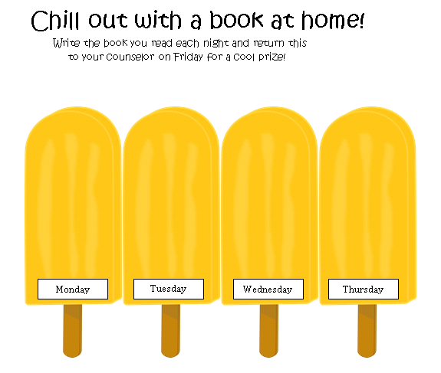

Sand pail- printed on colored cardstock and sand glued inside of bucket
